Emergency Food and Shelter Program
User Manual

An NTech Collaborative Project in conjunction with NTech Education Partner, Tulsa University

TABLE OF CONTENTS

Introduction 2
Navigation Bar 3
Login page 4
Client Search Page 5
Client Search Results 6
Client Benefits Page 7
Client Details Page 8
New Client Entry Form 9

INTRODUCTION

The purpose for the Emergency Food and Shelter Program website (www.efsponline.org) is to allow multiple agencies and users to access an online database of clients that have received funding for Rent/Mortgage, and/or Utilities from the participating organizations before. It also allows the systems’ users to enter new clients, and client information, into the database for future use. This system will create a resource for the agencies to prevent duplication of payments to clients asking for funding. Within the site, the users will be able to view, or enter, payment amounts and the payment type made to any client.

Navigation Bar

The navigation bar was designed to allow users to access important information quickly (See Figure 1). It includes links to 4 main pages: Home, Agencies, Contact, and Help. The Home tab takes the user directly to the Client Search Page. The Agencies tab takes the user to a page that shows the contact information of all the agencies associated with the site. The Contact tab allows users to view the contact information of the systems administrator in the event there is an error with the site.

Figure 1
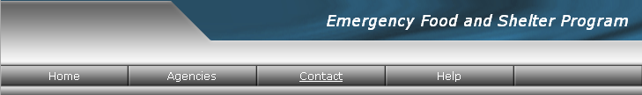

In the event that the page will not load and you cannot access the System Administrators contact information please contact the following person:

Top of Form
John Cory
Tulsa Area United Way
918-295-6626
jcory@tulsaunitedway.org
Bottom of Form

Login Page

The first page of the site is the Login page in Figure 2. Please enter your designated Login ID and Password in the correct boxes and click the Submit button. If you are unsure if you have access to this site, please contact the system administrator using the contact information given under the Contact link located in the upper right hand corner of the screen. If you need to reset the information entered into the boxes, click the Reset button and the previous information will be cleared. Once you have successfully logged onto the system you will be directed to the “Client Search” page.

Note: All passwords are case sensitive.

***If you forget your password please report it to the system administrator. The contact information will be located on the Contact tab of the navigation bar.

Figure 2
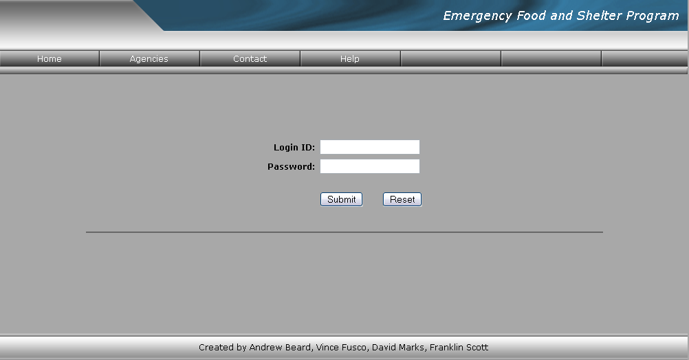

User Search Page

Figure 3
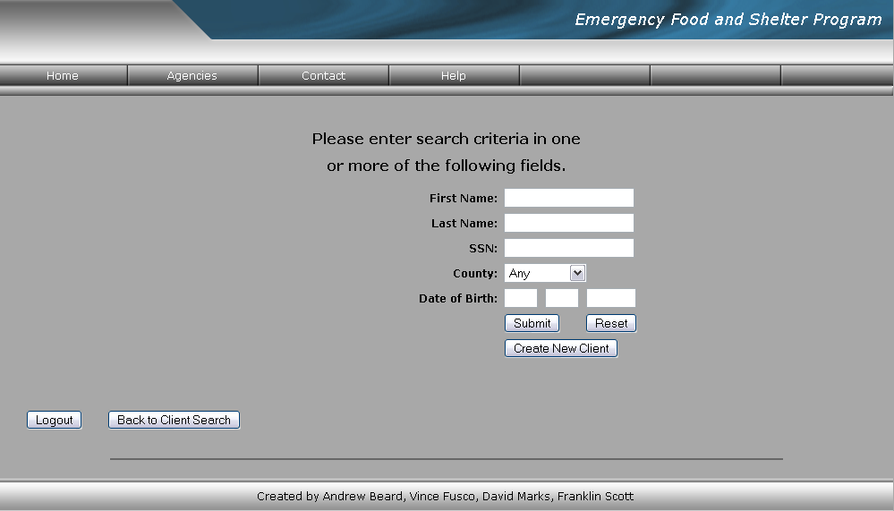

This search screen allows you to search for existing clients located in the database. Enter valid information into one of the search fields. You can search by one or up to 4 criterions. After entering the criterion into the fields, click the Submit button located directly below the fields to start the search. You will be directed to the “Search Results” page. The more fields you search by, the more specific the information retrieved. This means fewer results (clients) will appear on the search result page. If you are having trouble locating an existing client, try using fewer fields, such as Last Name, to find the client. If you need to clear the information in all fields click the Reset button.

Also located on this page is the option to create a New Client. This allows the user to enter a new client’s information into the system. If you would like to enter new clients into the system, click on the Create New Client button. This option will be discussed in greater detail in the “Creating New Client” section.

**As you will notice there is a Logout button located on this page. This will logout the current user and directs them to a page where they can log in as a different user if needed

User Search Results

The user search results page is where the results for a client search are displayed. If the search finds matching information in the database it will be displayed on this screen, Figure 4. If multiple results are found, they will be displayed in alphabetical order by the clients’ last name. By clicking on the clients name you will be directed to that clients Client Benefits page. Included in the search results with the clients name are the Date of Birth, SSN (last four digits), and the County they reside in.

If the search results show nothing, there is nothing in the database that matches the information that was entered on the previous page. IF this occurs, please click the Change Search Parameters button located above the search results to go back to the “Client Search” page and change the criterion. If the problem persists, try searching for fewer criterions on the “Client Search” page. If the search still shows no results it is likely that the client is not in the system.

If the client is not located in the system, click the Create New Client button to be directed to the “New Client” page, to enter the clients’ information into the system. Clicking on the Back to Client Search button will send the user to a blank “Client Search” page.

Figure 4
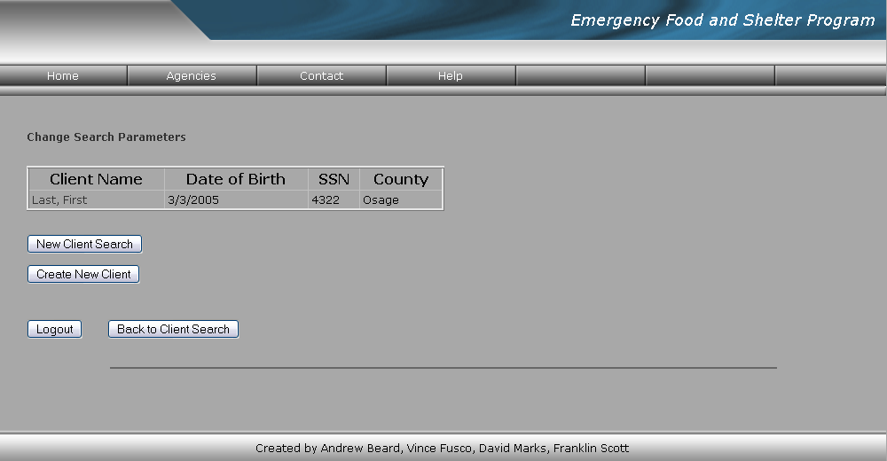

**As you will notice there is a Logout button located on this page. This will logout the current user and directs them to a page where they can log in as a different user if needed.

Client Benefits Page

The “Client Benefits” page shows the history of the clients’ assistance received. The assistance is divided by bill type (Utility or Rent) and listed in order from oldest to most recent. Follow steps 1 and 2 to enter an eligible assistance payment.

Step 1) Enter the Bill. To enter a Bill, select the occurrence type (Utility or Rent) from the drop down box under Add Bill. Enter the amount of the bill in the box under Amount. Enter the date of the bill in the box under Billing Date. Enter the account number in the box under Account Number. Click Submit. The Bill will be displayed as a Utilities Bill or a Rent Bill.

Step 2) Enter the Payment. To enter an eligible assistance payment for the bill entered in Step 1, find the Add Payment boxes located under the appropriate bill. Enter the eligible assistance payment amount in the box under Payment Amount. Enter the date of the application for assistance in the box under Application Date. Enter the date the assistance payment was made in the box under Funding Date. Click Submit. The payment history will be displayed under the appropriate Bill.

Figure 5
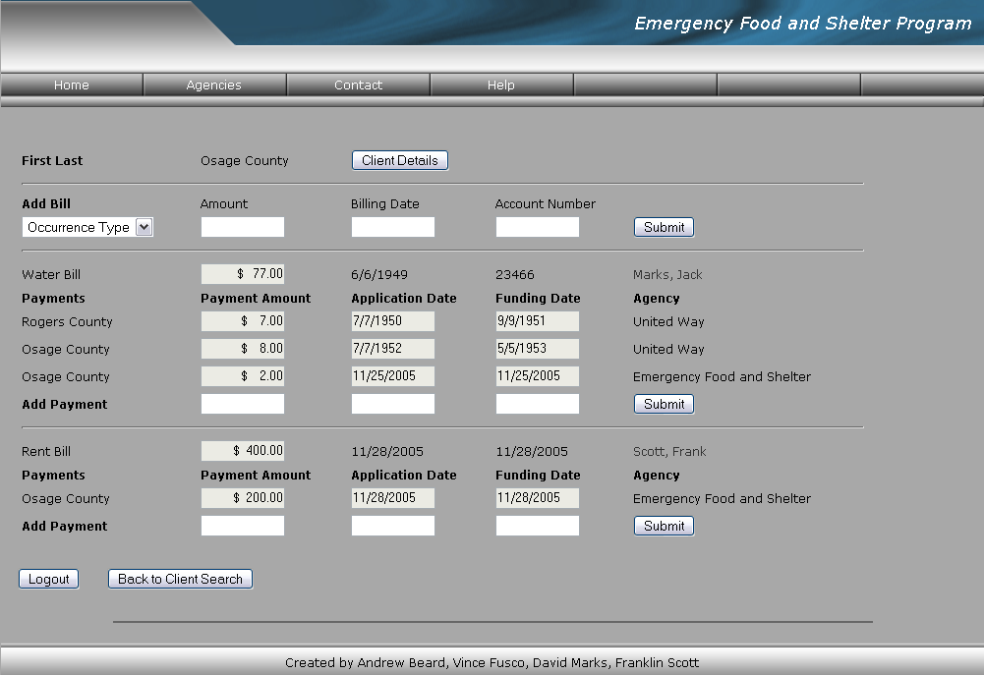

Near the top of the screen that there is a box labeled Client Details that will direct users to the “Client Details” page. This will allow users to change the clients’ basic information such as address, phone number, etc. At the bottom of the page there is also a button that will direct you to the “Client Search” page to begin a new search. A Logout button is also located at bottom of the screen.

Client Details Page

The “Client Details” page is where users can update client information. All of the clients’ information located in the database will be displayed on this page. In order to change certain information about a client just replace the existing information with the current information and click the Update button located directly below all the client fields. If you change the SSN of the client, you must type it into the SSN field and the Retype SSN field as well before clicking the Update button.

Directly below the “Navigation Bar” is a button labeled Bills and Payments, this will take you to the “Client Benefits” page where payment information of the client can be viewed or updated.

Located at the bottom of the page is a link, Back to Client Search, which will direct the user to the “Client Search” page to allow for a new client search to begin.

Figure 6
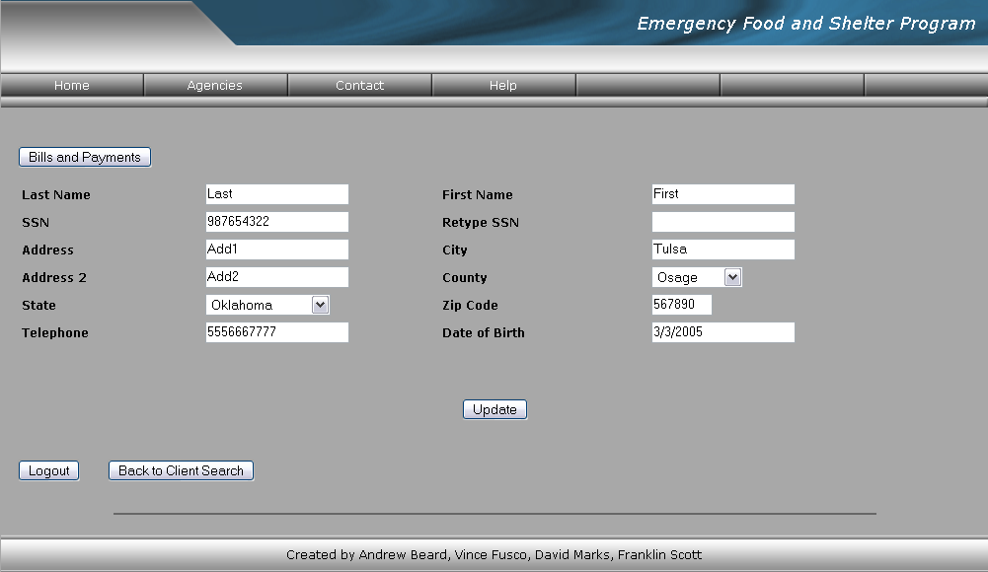

**As you will notice there is a Logout button located on this page. This will logout the current user and directs them to a page where they can log in as a different user if needed.
New Client Entry Page

The “New Client” page allows users to enter new clients into the system so that payment information can be recorded that is related to the client. It is important that all of the information is entered correctly so that it can be used effectively. All fields with an * located to the right of the box are required information.

Figure 7
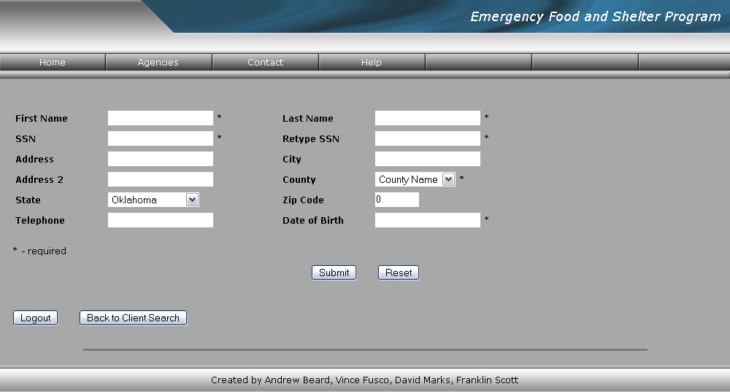

**As you will notice there is a Logout button located on this page. This will logout the current user and directs them to a page where they can log in as a different user if needed

